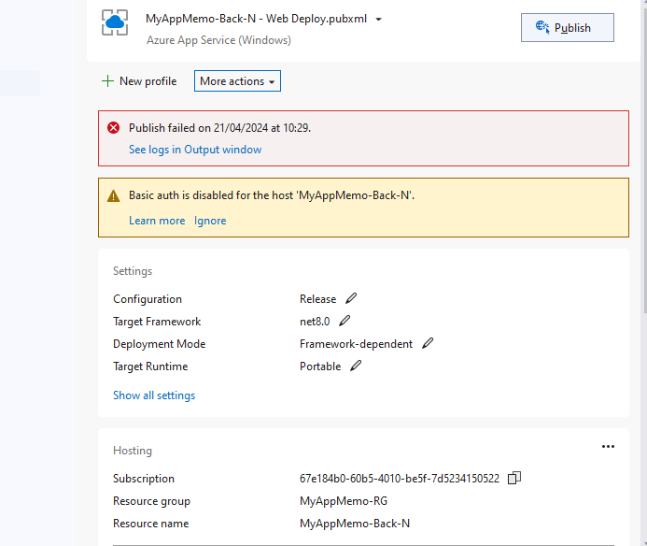
Enable Basic Authentication: If possible and if it aligns with your security requirements, you can enable basic authentication for the Azure Web App host (MyAppMemo-Back-N). This would allow Visual Studio to authenticate and deploy your application successfully. You can enable basic authentication in the Azure portal by navigating to the Authentication / Authorization settings for your Azure Web App.

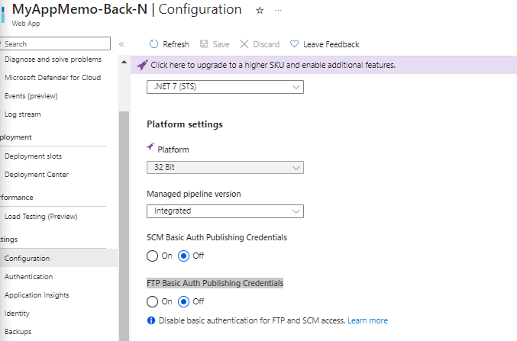
A
Problem with root path, swagger file
